**Experiment 23:** Database as a Service (DaaS) create and configure a new VM Image in any Public Cloud Service Provider.

Step 1: Click on Connect option.

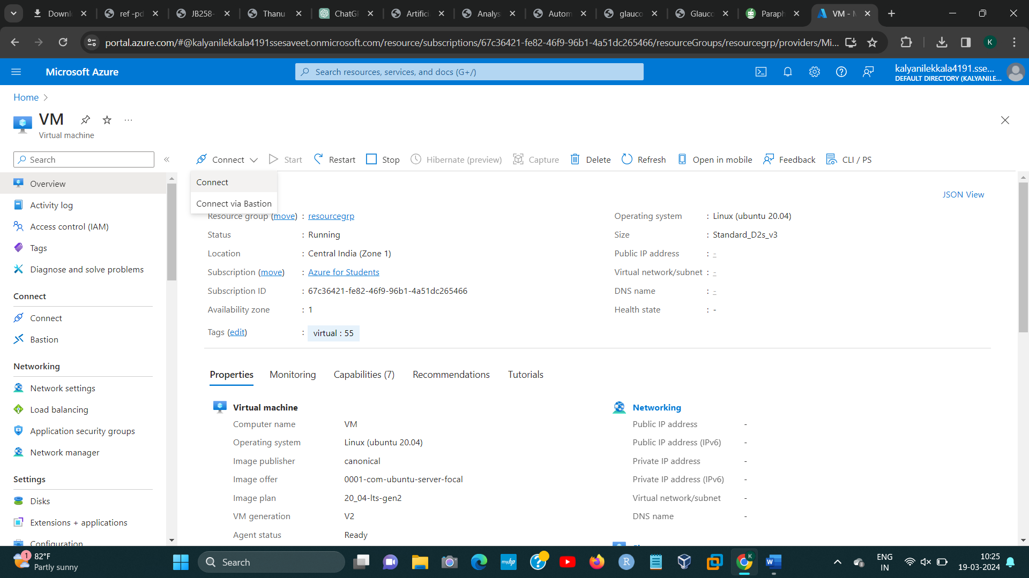

Step 2: Click on Select Option.

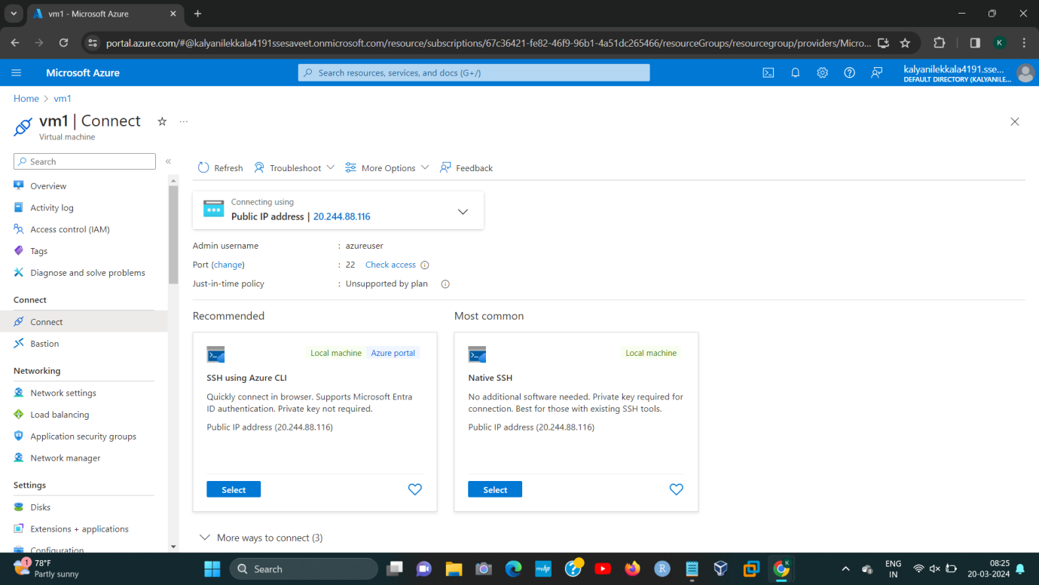

Step 3: Here the Command Will Appear.

